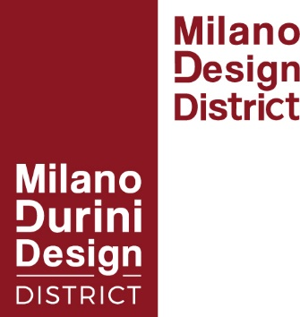
Design week 2022
From Milano Durini Design to Milano Design District
Not only Durini: the MDD Association's new in-house concept, the 'Milano Design District', brings together the city centre's flagship design stores in a spirit of cohesion and partnership.

The Milano Durini Design Association is constantly growing and today counts 42 members, including the most important design brands known worldwide.
So at the behest of companies in the city centre MDD, the Milano Durini Design District, has created a new, more participatory and inclusive in-house brand:
The MILANO DESIGN DISTRICT.
The aim is to create a collaborative partnership project to unite Design excellence in the city centre. An URBAN DESIGN HUB with recognisable value and content, on a par with other important international design districts like the Miami Design District, the London Design District and the Shanghai Design District,

While the association is still known as Milano Durini Design, the association’s new brand, as of Design Week 2022, will be the
MILANO DESIGN DISTRICT

Milano Durini Design was founded in 2016 by seven major companies on Via Durini and its then patron, architect Massimo Salamone.
“The Milano Durini Design association is constantly growing, with the opening of new brand stores that have chosen to be part of this exclusive organisation in a constantly developing city,” says President Massimo Salamone. “The Association is getting bigger, and we are delighted to welcome top brands in the lighting, outdoor and interiors sectors and stores in Via Santa Cecilia and Corso Monforte this month.”
Over the years, an increasing number of companies in the city centre have applied to join the MDD association, sharing its aims of synergically redeveloping their city district and promoting shared actions for greater representation at a national and international level.
In recent years, companies have asked that participation in Milano Durini Design be increasingly inclusive and open to brands not located in or around Via Durini.
The Milano Durini Design association welcomed this request and shares its aims, including making the association and the city centre's 'Milano Design District'” more dynamic, through social and cultural involvement, with exhibitions and events throughout the year. After Design Week, there will be a larger upcoming project in which the district will be transformed into a diffused art college.

Milano Design Week 2022
As part of the Milano Design Week 2022 (from 6th to 12th June 2022) several leading companies in the sector that are members of the Milano Durini Design Association will showcase the results of their efforts and work to fellow professionals and the public, presenting new products against unique and evocative backdrops. This underlines the current dynamism and is an important economic commitment to the country's recovery and Milan's strategic representation internationally.
Once again, the Milano Design District is dedicated to promoting the culture of design and the concept of ‘Made in Italy’ during Design Week. Inside the showrooms (with over 20,000 m$2$ of space devoted to the world of design) there will be a wide range of events promoting design, including talks, exclusive, unprecedented product showcases, interaction between the public and sector professionals, and special exhibitions and opportunities to reflect on the themes of Design, Lifestyle and Sustainability.

The theme of this year’s urban street project is Life&Nature Design: an urban forest will be set up in its various stages of growth with birches, hornbeams, perennial flowers and grasses.
An evocative emphasis will be placed on the importance of alternating cycles and respect for the environment as part of the production process, in which every element needed to create a design product - whatever it may be - must be in harmony and balance with the others.

Milano Design District ………………. Where the heart of Design beats

