SUSPENDED ABOVE THE WATER
AZIMUT YACHTS TRANSFORMS THE DARSENA FOR MILANO DESIGN WEEK 2023 WITH “THE SEA DECK”, AN ORIGINAL INSTALLATION BY
AMDL CIRCLE AND MICHELE DE LUCCHI

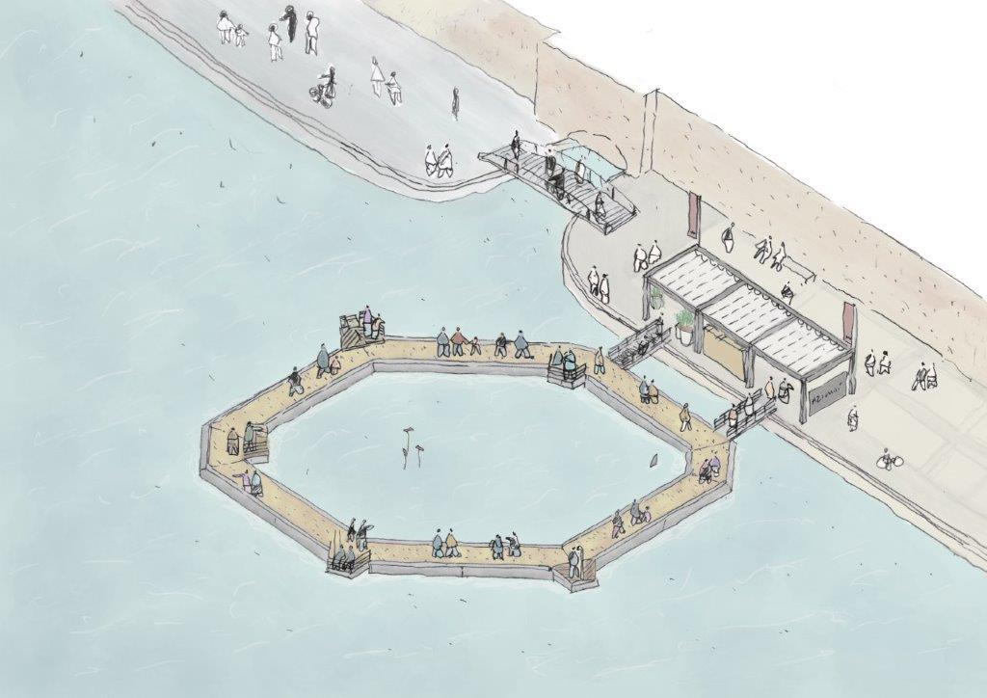
Credits Nicholas Bewick - AMDL CIRCLE

From the 17th to the 23rd of April, Azimut Yachts presents “The Sea Deck,” the floating installation that recounts the desire to go beyond the expected and – as with the yachts of the Seadeck Series – rediscover contact with nature. It is both an emotional walk on the water and a journey to discover the route traced by Azimut to protect the sea.

In the nautical world, Azimut has realized the ideal of returning to nature: the Shipyard was the first to combine technological solutions to reduce environmental impact with stylistic and design innovations aimed at breaking down the barriers between inside and outside to embrace the sea once again. The symbol of this approach is the new Seadeck Series, the first hybrid Series of motoryachts for families, which will achieve a 40% reduction in CO2 emissions in an average year of use compared to a traditional flybridge boat of similar size.

The new Seadeck Series, epitomizing this philosophy, has inspired AMDL CIRCLE and Michele De Lucchi in the creation of "The Sea Deck", a floating promenade on the Darsena, designed in collaboration with Azimut to bring the experience of the ancient navigable waterways back to the city of Milan and offer visitors a new perspective on enjoying the water from a unique point of view near Leonardo da Vinci's historic canal. The project was designed to re-propose the same revolution that Azimut has introduced in the nautical world, inviting you to embark on a journey to discover the technologies developed by the Shipyard to reduce environmental impact and to share a moment of return to nature, which is the essence of navigation.

In fact, the installation reinterprets the aft terrace of the Seadeck Series yachts, the Fun Island, which is an open lounge embracing the sea, designed for the first time to offer an immersive experience in nature: it is accessed from the quay through a covered stand that recalls the architectural identity developed over the years by AMDL CIRCLE for Azimut. Once on board, visitors will be able to walk – strictly barefoot – along the ring, suspended above the water, to the center of the Darsena and satisfy that desire to “go further”, the part of Azimut's pioneering DNA that nourishes sea explorers. Along the way, five interactive stations open on cantilevered terraces, referencing the openable "wings" of Seadeck yachts, to teach the path traced by the Shipyard to reduce emissions and energy consumption, the "green heart" of the Seadeck Series: from the new hybrid engines to the onboard systems that reduce energy absorbtion, on to the with the installation of solar panels and the use of recycled materials and including the carbon adopted to lighten the upper parts by up to 30%. In the evening, the LED lighting evokes the same emotions as boat lights shimmering on the water.

The installation created by Azimut in collaboration with AMDL CIRCLE and Michele De Lucchi has the patronage of the Municipality of Milan for the values of sustainability and circularity according to which it was created. The Seadeck Series combines technological solutions with the use of natural, recycled and recyclable materials. AMDL CIRCLE looked to these in defining this project for the fuorisalone: as on the yachts of the series, the traditional teak is replaced by cork, an effective and more sustainable alternative, and the decking of the installation was made from 2 million recycled and ground bottle corks, which will then be transformed again into insulating material for architecture, further reducing its environmental impact. Collected by volunteers on behalf of the Arts & Crafts Cooperative of Cuneo, the corks, all from Italy, were treated by Amorim Cork, which has long been involved in raising awareness about how cork’s important role in the ecological equilibrium of the world.

From the first step onto cork, the ancient raw material symbolic of the Mediterranean, visitors will enter another world, an unprecedented place for sharing urban space and reconnecting with the most powerful and regenerative of elements, water.

Azimut, AMDL CIRCLE and Michele De Lucchi are meeting the visitors of Milan Design Week near the Leonardo canal from the 17th to the 23rd of April to discover, in this unusual relaxation space, a new connection with the waters of the historic Navigli.

Azimut Yachts
Azimut Yachts, founded by Paolo Vitelli in 1969 and part of the Azimut|Benetti Group, offers owners around the world a wide range of motor yachts from 42 to 125 feet in length, organised in six lines (Verve, Atlantis, Magellano, Flybridge, S and Grande). The brand stands out for the spirit of innovation that puts it at the forefront of trends and solutions in technology and design recognised throughout the world of yachting. With headquarters in Avigliana (Turin), Azimut Yachts has five production facilities in Italy (Avigliana, Fano, Viareggio, Savona and Varazze) and one in Brazil, in Itajai, and a presence in 80 countries through a network of 136 sales and customer service centres and representative offices in Shanghai, Hong Kong, Fort Lauderdale and Itajai. For more information: azimutyachts.com.

AMDL CIRCLE
AMDL CIRCLE is a multifaceted studio that was founded by Michele De Lucchi. Internationally renowned for its humanistic approach, it works across many sectors providing its clients with expressive and strategic projects that embrace architecture, interiors, products and communication. AMDL CIRCLE’s team of architects, designers and craftspeople have worked on projects for public and private organisations, collaborating with large corporations such as Intesa Sanpaolo, Deutsche Bank and UniCredit, and designing buildings and exhibition systems for Neues Museum in Berlin and the Gallerie d’Italia in Milan, Turin and Naples. The Milan based studio has also designed spaces, products and furniture for Alessi, Artemide, Cassina, Hermès, Poltrona Frau and UniFor. For more information:amdlcircle.com

PRESS CONTACTS:

Head of Media Communication - Azimut  Laura Sandrone  laura.sandrone@azimutbenetti.com  Press Office Azimut|Benetti Group  Sculati and Partners  T. +39 02.99253500  office@sculatiandpartners.com | Communication – AMDL CIRCLE  Valentina Brivio  v.brivio@amdlcircle.com media@amdlcircle.com  Press contact The Sea Deck event: GWEP public&media relations  Guendalina Perelli +39 329 9388286  Lucia Legé +39 338 2365852  Raffaella Tosi +39 392 5255057  press@gwep.it

