Press Release  MILAN DESIGN WEEK 2022  Address: Viale Umbria 49, 20135 Milan,  MM Metro 3, stop Lodi TIBB  Dates/Times:  - June 6 -11 | 11 am - 8 pm  - Sunday, June 12 | 11 am - 5 pm  - Press Preview: Wednesday, June 8 – 9 am - Noon | Media Contact:  Patrizia Ledda | MAP Design Communication  Info@mapdesign.it  ph +39 3394766974

SUPERBLOOM
Los Angeles-based design collective RIOS presents Superbloom, an immersive and joyful exhibition bringing Southern California blooms to Milan

RIOS designs Superbloom, a tantalizing multisensorial journey through colors, scents, and sounds as a tribute to the natural and rare phenomenon of a superbloom.

"RIOS is an international multidisciplinary design collective. We are passionate believers that design is an act of optimism and can be a conduit for creating harmony in the awareness of places, people, and cultures," says Sebastian Salvadó, Creative Director and Partner at RIOS. "We look forward to inviting visitors to our debut Milan exhibition Superbloom. They can join us in an immersive experience inspired by our local desert bloom, which every year inspires people to come together in a joyous engagement with nature."

Superbloom will welcome visitors to a vivid sensory-filled exhibition that orients them through three rooms, each building a crescendo of activity as one approaches the final space. These rooms create simulations of biological processes such as the watering, propagation, and blooming of wildflowers, a phenomenon globally but particularly spectacular in Southern California, where RIOS is based.

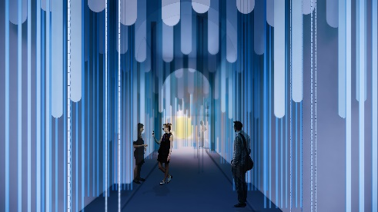

As visitors experience the exhibition, they will journey through the Rain Room, which sets the stage for blooms in nature. An earthy aroma and track of arrhythmic tones and echoes simulate falling rain.

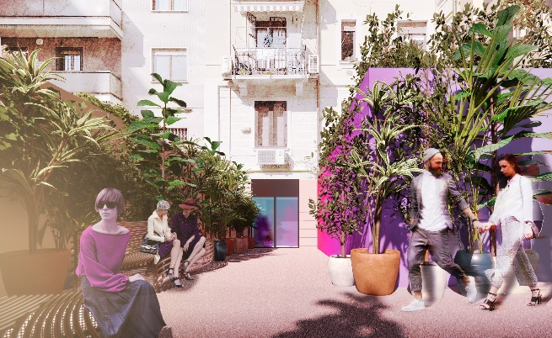

In the distance, the sun beckons visitors to the Sprout Room, which transitions one to the fresh air and greenery, that has not yet matured to its hyperbolic state. Colors shift from deep to bright, dappled sounds will fade into a wild field, and scents will be aromatic, woody, and fresh. Rio Benches, designed by RIOS in collaboration with Janus et Cie, are positioned throughout to offer a moment of respite.

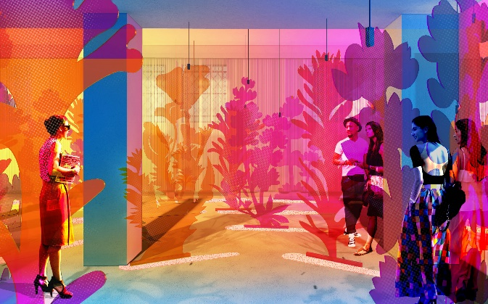

Visitors are welcomed to an otherworldly dimension as they approach the Bloom Room. Filled with exaggerated and vibrant floral installations and scents that evoke a joyful experience reflective of nature’s reemergence and the concentration of energy of the Superbloom. The Bloom Room is the space of being “reborn,” where projected images and play on light are accompanied by melodic music.

“The inspiration of our exhibition is to connect people and unite the audience of Milan Design Week in a shared experience in recognition that moments of gathering, like those of a Superbloom, no matter how fleeting, can be powerful for making community,” says Salvadó.

RIOS’ Superbloom exhibition will run from June 6 – 12th and extend through July. For more information visit
www.rios.com

After the design week, thanks to Milan-based design agency Esther Burton, the exhibition items will be donated to 'Ai.Bi. Associazione Amici dei Bambini’, a non-profit association fighting child neglect in Italy and worldwide as well as supporting refugee Ukrainian mums with their kids in Italy. Instead of being discarded, Superbloom's colours will bring joy in the playrooms of local welcoming centres.

Superbloom partners: JANUS et Cie, P.F. Candle Co, Syng, notNeutral, 80plus Coffee Roasters, Dalla Corte.

Instagram
@rios.imagines #superbloomRIOS #MDW2022, #riosimagines #RIOSinMilan
CREDITS: Matteo Cirenei

###

About RIOS: RIOS is an international design collective working beyond boundaries to inventively combine disciplines and amplify the impact of design. Combined, our talents comprise a wide range of professional skills including architecture, landscape, urban planning, interior design, video, graphics and signage, experiential, and product design. Our work is irreversibly connected to the narrative of place and the complex order of human culture, creating solutions that are joyful, authentic, and unexpected. Our projects are diverse, including commercial, civic, hospitality, institutional, and residential.

Recently completed projects by RIOS include Spotify’s Content Campus, the headquarters of GoodRx, the Jardin de la Réciprocité at the prestigious International Garden Festival Domaine du Chaumont-Sur-Loire and the Lawrence J. Ellison Institute for Transformative Medicine. For more information visit www.rios.com

June 6, 2022

